DAY-2
NAME: SARAVANAVELU.D REG NO:192224249
- Division:

Input:
x <- 100
y <- 20
z <- x/y
print(paste("Division of two numbers is:",z))
Output:
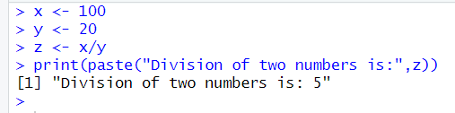
- Histogram:
Input:
# Create data for the graph.
v <- c(19, 23, 11, 5, 16, 21, 32,
14, 19, 27, 39)

# Create the histogram.
hist(v, xlab = "No.of Articles ",
col = "green", border = "black")
Output:
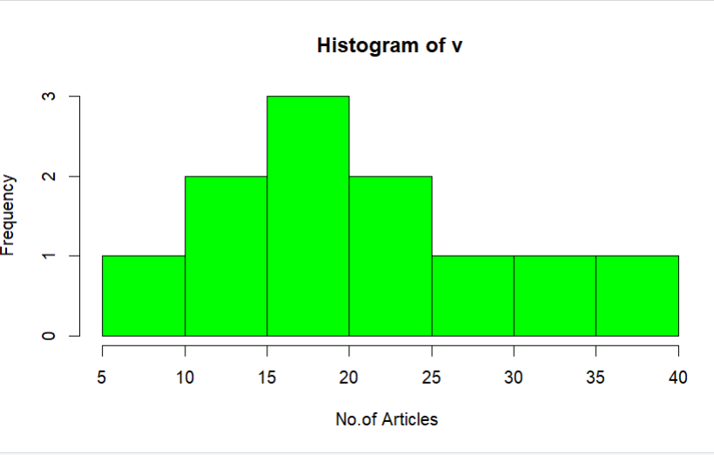
3.Linear regression:
Input:
# Create the data frame
data <- data.frame(
Years_Exp = c(1.1, 1.3, 1.5, 2.0, 2.2, 2.9, 3.0, 3.2, 3.2, 3.7),
Salary = c(39343.00, 46205.00, 37731.00, 43525.00,
39891.00, 56642.00, 60150.00, 54445.00, 64445.00, 57189.00)
)
# Create the scatter plot
plot(data$Years_Exp, data$Salary,
xlab = "Years Experienced",
ylab = "Salary",
main = "Scatter Plot of Years Experienced vs Salary")
Output:
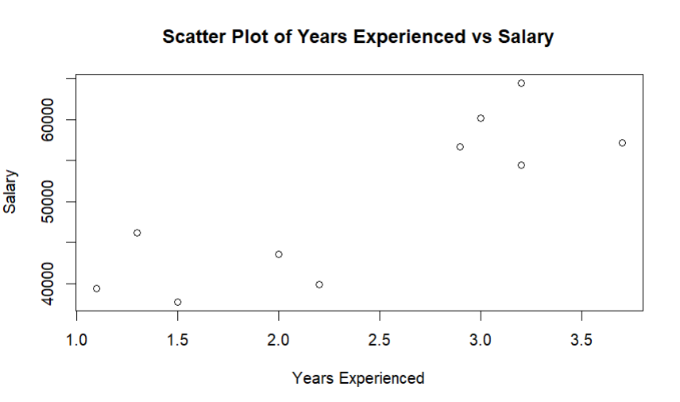
4.Median
Input:
# vector of marks
marks <- c(97, 78, 57, 64, 87)
# find middle number of marks
result <- median(marks)
print(result)
Output:
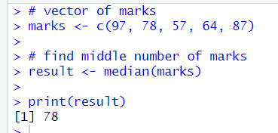
5. Min max normalization:
Input:
# create a vector
data = c(23, 4, 56, 21, 34, 56, 73)
# get the minimum value
print(min(data))
# get the maximum value
print(max(data))
Output:
